Mathematics depends of people who make it and eras they live in. So the needs of everyday life like trading and construction encouraged development of mathematics in India. But symphaty toward exuberance, wealth and big numbers also left a big mark in Indian mathematics. They liked numbers like: one million billion (10¹⁵), twenty four thousands of billions (24x10⁹) , six thousands...
Indian mathematics predominantly dealed with algebra and arithmetics unlike greek mathematics which mostly dealed with geometry. There are no big books in Indian literature dedicated to mathematics. So math takes little part in books about astronomy and astrology.
THE BEGINNINGS OF THE DEVELOPMENT
Indians brought in special characters for numbers from zero to nine in Indian decade system and it lead to great developement of their mathematics. Those characters are very similar to ours, but it is like that because we got their number system with the help of araps. Unlike Babylonians, Indians used positional notation only for integers, but not for fractions. Indians discovered zero later than Babylonians, but Indians had more sofisticated notation for numbers than Babylonians.
The oldest records of early forms Indian notations of numbers are stone columns which are built by Maura – empire emperor Asoka in every larger city about 3 centuries BC. Indian discovery of zero is closely related to Indian philosophy and religion. Discovery of zero certainly enabled easier computing. There was no longer need for computing boards with lines and columns.
HOW DID THEY COUNT
Here is an example of multiplication on computing board. They sprinkeled board with sand and then draw fields with a stick and then wrote and erased numbers.
multiplication of 415 and 327:
They wrote these two numbers in main row and column, and then they wrote parcial product of corresponding numbers in diagonally divided fields. E.g. in third field of first row they would write one and five, because three times five is fiftheen. Sign for zero wasn't needed because it was enough to leave empty field. Then they would add numbers by „dyagonal stripes“, starting from bottom right angle (with transfers of possible tens in left stripe).
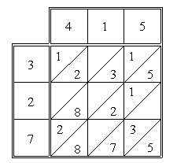
Indians loved telling mathematical tasks a bit like poetry. E.g. „One fifth of swarm of bees dropped on Kadamba flower, and one third on Silindhe flower. Triple difference of those numbers flew of of Kutua flower. There was only one bee left, equally attracted to Jasmin and Pandam flower. Tell me, lovely woman, how many bees were there in the swarm?“
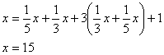
Indians often solved algebraic – arithmetical problems by inversions. It's the procedure of solving a problem inversely of the order it was given. Starting from the end to the first number you switch one operation by it's opposite operation (addition by subtraction).
E.g. „Lovely girl with shiny eyes, tell me, in your knowing of right process of invesion, what is the number: when you multiply it by 3, and then add ¾ of that product to that number, and then divide it by 7, and then subtract 1/3 of quotient from that number, and then multiply number by itself, then decrease it by 52, then get square root of it, add 8, divide by 10 and you get 2?“
Procedure of solving: Number which divided by 10 gives 2 is 20. We got that number by adding 8 to 12. 12 is square root of 144. Number which decreased by 52 gives 144 is 196. 196 is 14 multiplied by itself. Number which decreased by ¾ gives 14 is 21. Number which divided with 7 gives 21 is 147. Number which increased by ¾ of that number gives 147 is 84. We get that number by multiplying 3 and 28. Solution is number 28.
THE MOST IMPORTANT ACHIEVEMENTS
Indians had very good approximations of number ∏. They replaced it with:
They also had very good approximation of accurate to five decimal places:
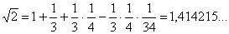
Indians also knew about „Ancient Egyptian“ triangle with sides 3,4,5, and right angled triangle with sides 15, 36, 39. They also knew about more general Pythagorean triplets of numbers in sixth century BC.
It's considered that they made general proof of Phytagora's theorem:
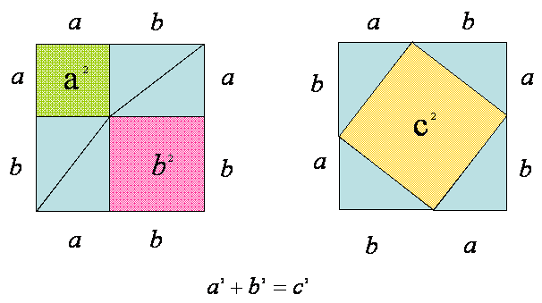
OLD INDIAN MATHEMATICIANS
Greatest and most important old Indian mathematicians are:
- Aryabhatta (V.st.)
- Brahmagupta (VI.st.)
- Mahavira (IX.st.)
- Bhaskara (XII.st.)
Aryabhatta knew how to calculate square and cube root by dividing radicants in groups of two and three digits (in principle it's what we do today).
Brahmagupta knew how to find integer solutions for some quadratic equations like:
This type of solving, where you find only integer solutions of equations and systems of equations was named after Greek mathematician Diofant althought Indians knew it much earlier.
Indians knew how to solve quadratic equations like
using the method of solving which L. Euler „discovered“ in 18th century.
Mahavira dealed with elementary mathematics.
Bhaskara proved Phytagora's theorem using properties of similarity of triangles (Europeans proved that in XVII. Century).
Bhaskara's proff:
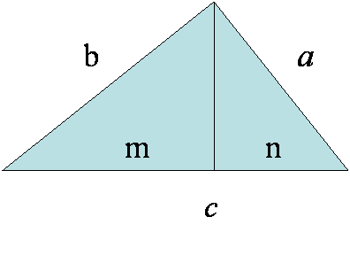

From:
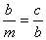 , 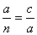, ,
we get : .
In Bhaskara's texts there are many things that sound „modern“. He even wrote about division by zero. He told that when you divide some number with very small number that is almost zero, you will get very large quotient, i.e. infinity.
After Bhaskara, Indian mathematic stagnated and even regressed until 20th century.

